Name: | Muhammad Taha
CMS ID: | 518133

Lesson Set  9 | Introduction to Functions  And Recursion
Purpose | - Understand the purpose and usage Functions.  - Awareness of functions with syntax and rules.  - Introduction to recursion and its usage
Procedure | - Students should read the Pre-lab Reading Assignment before coming to lab.  - Students should complete the Pre-lab Writing Assignment before coming to lab.  - In the lab, students should complete Labs 9.1 through 9.2 in sequence.  - Your instructor will give further instructions as to grading and completion of the lab.  - Students should complete the set of lab tasks before the next lab and get them checked by their lab instructor.
 | Contents | Pre-requisites | Completion Time | Page Number
 | Pre-lab Reading Assignment | - | 20 min
 | Pre-lab Writing Assignment | Pre-lab Reading | 10 min
 | Lab 9
 | Lab 9.1  Working with Nested for loop | Understanding Nested for loop | 30 min
 | Lab 9.2  Working with Nested while loop | Understanding Nested while loop | 30 min

Pre-lab Reading Assignment

Functions | A function is a set of statements that take inputs, do some specific computation, and produce output. The idea is to put some commonly or repeatedly done tasks together and make a function so that instead of writing the same code again and again for different inputs, we can call the function. In simple terms, a function is a block of code that only runs when it is called.  Dividing a complex problem into smaller chunks makes our program easy to understand and reusable.  There are two types of functions:  Standard Library Functions: Predefined in C++  User-defined Function: Created by users  C++ User-defined Function  C++ allows the programmer to define their function.  A user-defined function groups code to perform a specific task and that group of code is given a name (identifier).  When the function is invoked from any part of the program, it executes the codes defined in the body of the function.  C++ Function Declaration  The syntax to declare a function is:  returnType functionName (parameter1, parameter2,...) {  // function body  }  Calling a Function  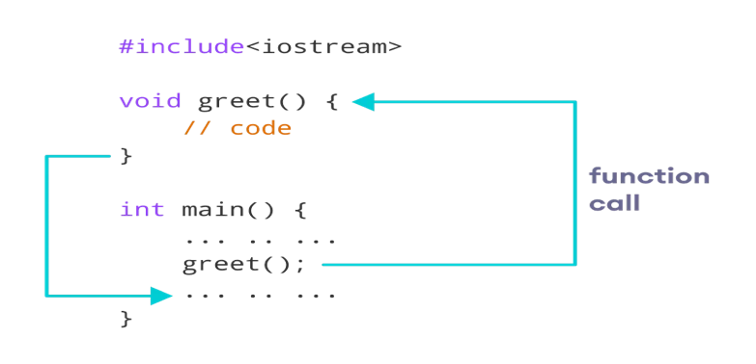  Function Parameters  As mentioned above, a function can be declared with parameters (arguments). A parameter is a value that is passed when declaring a function.  For example, let us consider the function below:  void printNum(int num) {  cout << num;  }  Here, the int variable num is the function parameter.  We pass a value to the function parameter while calling the function.  int main() {  int n = 7;  // calling the function  // n is passed to the function as argument  printNum(n);  return 0;  }  Function Prototype  In C++, the code of function declaration should be before the function call. However, if we want to define a function after the function call, we need to use the function prototype. For example,  // function prototype  void add(int, int);  int main() {  // calling the function before declaration.  add(5, 3);  return 0;  }  // function definition  void add(int a, int b) {  cout << (a + b);  }  In the above code, the function prototype is:  void add(int, int);  This provides the compiler with information about the function name and its parameters. That's why we can use the code to call a function before the function has been defined.  C++ Recursion  When the function is called within the same function, it is known as recursion in C++. The function which calls the same function is known as a recursive function.  A function that calls itself, and doesn’t perform any task after function call, is known as tail recursion. In tail recursion, we generally call the same function with a return statement.  C++ Function Overloading  Function Overloading is defined as the process of having two or more functions with the same name, but different in parameters is known as function overloading in C++. In function overloading, the function is redefined by using either different types of arguments or a different number of arguments. It is only through these differences compiler can differentiate between the functions.  The advantage of Function overloading is that it increases the readability of the program because you don’t need to use different names for the same action.  Example: changing the number of arguments of the add() method  // Program of function overloading with different types of  // arguments.  #include <iostream>  using namespace std;  int mul(int, int);  float mul(float, int);  int mul(int a, int b) { return a * b; }  float mul(double x, int y) { return x * y; }  int main()  {  int r1 = mul(6, 7);  float r2 = mul(0.2, 3);  cout << "r1 is : " << r1 << endl;  cout << "r2 is : " << r2 << endl;  return 0;  }

Pre lab writing assignment
Fill in the blanks | - Function is a block of code that only runs when it is called.  - Function divides a complex problem into smaller chunks make our program easy to understand and reusable  - function with the same name, but different in parameters is known as function overloading  - A function that calls itself, and doesn’t perform any task after function call, is known as tail recursion.

Lab 9
Lab 9.1 | - Once you have opened the visual studio copy the following code in the code editor, try to run the code and observe the output. Write down the output that appears on the screen in the space given below  #include<iostream>  using namespace std;  int fact(int n){  int factorial = 1;  for (int i = 2; i <= n; i++){  factorial *= i;  }  return factorial;  }  int main(){  int n;  cin>>n;  int ans = fact(n);  cout<<ans<<endl;  return 0;  }  PS F:\Programming Fundamental\Labs\Lab 09> g++ test.cpp  PS F:\Programming Fundamental\Labs\Lab 09> .\a.exe  23  862453760
Lab 9.2 | Create a new project with new file with name lab9_2.cpp extension, copy the following code it and try to fill the missing code of the program. Observe the output that appears and write it in the box given below  using namespace std;  int fib(int n){  int t1 = 0;  int t2 = 1;  int nextTerm;  for (int i = 1; i <= n; i++){  cout<<t1<<endl;  nextTerm = t1 + t2;  t1 = t2;  t2 = nextTerm;  }  return 0;  }  int main(){  int n;  cin>>n;  fib(n);  return 0;  }  PS F:\Programming Fundamental\Labs\Lab 09> .\a.exe  9  0  1  1  2  3  5  8  13  21
Lab 9.3 | - Create a new project with name lab9_3.cpp extension, copy the following code it and try to run the program. Observe the output that appears and write it in the box given below  #include <iostream>  using namespace std;  int fibonnaci(int x) {  if((x==1)||(x==0)) {  return(x);  }else {  return(fibonnaci(x-1)+fibonnaci(x-2));  }  }  int main() {  int x , i=0;  cout << "Enter the number of terms of series : ";  cin >> x;  cout << "\nFibonnaci Series : ";  while(i < x) {  cout << " " << fibonnaci(i);  i++;  }  return 0;  }  PS F:\Programming Fundamental\Labs\Lab 09> .\a.exe  Enter the number of terms of series : 7  Fibonnaci Series : 0 1 1 2 3 5 8

Lab 9.4 | Lab Tasks

- Define two functions to print the maximum and the minimum number respectively among three numbers entered by the user.

Name: Muhammad Taha CMS ID : 518133
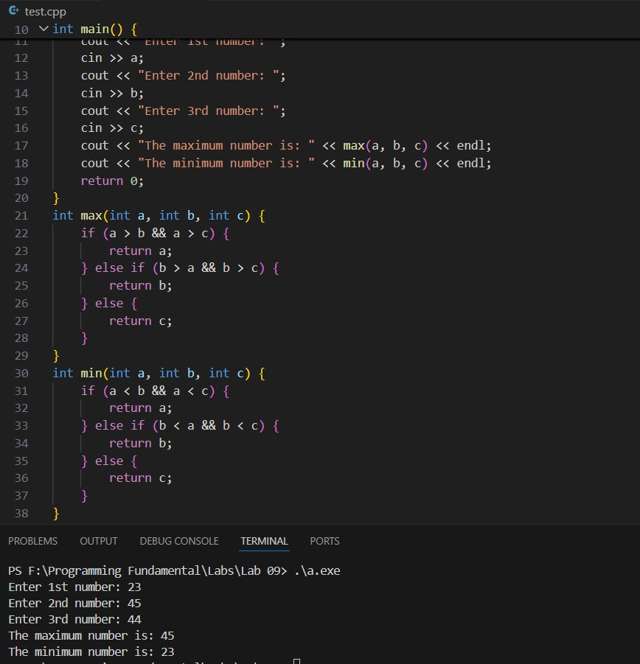

- Write a program that will ask the user to enter his/her marks (out of 100). Define a function that will display grades according to the marks entered as below:

Marks Grade
91-100 AA
81-90 AB
71-80 BB
61-70 BC
51-60 CD
41-50 DD
<=40 Fail

Name: Muhammad Taha CMS ID : 518133
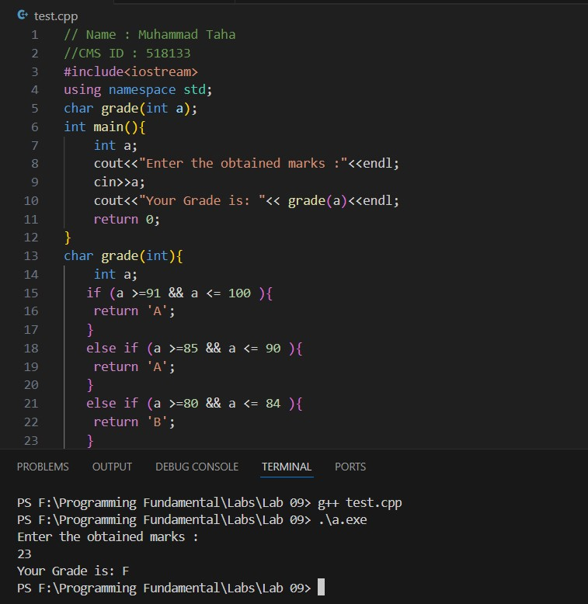

- Write a C++ program that takes an integer as input and reverses its digits using recursion.

Original number: 12345, Reversed: 54321
Original number: -9876, Reversed: -6789

